Live a more comfortable retirement
without selling your home
We have a retirement income gap
We are living longer than ever before. Unfortunately, not everyone has enough savings to fund their retirement and many Australians are unable to enjoy the retirement they deserve. But downsizing or relying on credit cards are not the only options available.​
What is a reverse mortgage?
A reverse mortgage is like a regular home loan that has been designed to meet the needs of seniors. It could allow you to access the equity in your home to fund a more comfortable retirement, while continuing to own and live in your home.
The benefits of a reverse mortgage
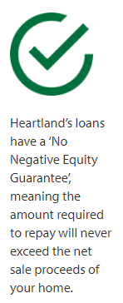 | No regular repayments are required, though dependent on reverse mortgage provider voluntary repayments may be made. |  |  | 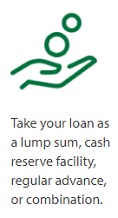 | Some reverse mortgages can be tailored to provide flexible access to what you need, when you need it, through a lump sum, regular payments, cash reserve, redraw or a combination.
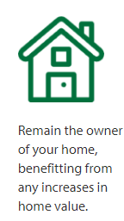 | Funds are usually used to make retirement more comfortable. For example, to consolidate debt, fund home repairs, travel, or relieve bill stress. |  |  |  | Australian reverse mortgages have a No Negative Equity Guarantee – enshrined in law. Subject to compliance with the loan conditions, your loan will never exceed the net sale proceeds of your home.
 | Importantly, you continue to 100% own your home and are able to live there as long as you wish. |  |  |  | The amount you are able to borrow depends on factors including your age and home value.
Reverse mortgage customers describe  their experiences  [place your own customer feedback here] |  |  |  |  |  | 
Some important considerations
Could a reverse mortgage affect my pension? |  | You can usually access some of the equity in your home without impacting government entitlements. However, you should contact Centrelink to discuss your particular financial situation.
What costs are involved? |  | Loan interest is compounding, which means the loan balance increases over time as interest is added to the loan. There are fees and charges for setting it up, including for your independent legal advice.
When is the loan payable? |  | At the end of the term of your loan (when you move permanently from your home) the total loan will then be payable. This is usually from the sale of the property, passing away, or moving to aged care.
For more information, please give NAME a call on 0000 123 123
Your information  Your information |  |  | YOUR COMPLIANCE/IMPORTANT NOTICE (or terms)

